[Date]

Hon Mark Furner MP
Minister for Agricultural Industry Development and Fisheries
PO Box 46
BRISBANE QLD 4001

Correspondence via email: agriculture@ministerial.qld.gov.au

Re: it is time to review the current legislation/regulations of enclosed yabby traps

Dear Minister,

I am writing to bring to your attention the cruel and indiscriminate drowning deaths of air-breathing semi-aquatic wildlife such as platypuses, rakali, water dragons and freshwater turtles caused by enclosed yabby traps such as opera house nets. I believe that it is time to review the current legislation/regulations and implement a ban on enclosed yabby traps to protect our precious wildlife.

Enclosed yabby traps are banned in Victoria, Australian Capital Territory, Tasmania, and Western Australia. Most recently, the New South Wales Government is giving away 5,000 open-top pyramid nets to recreational anglers as part of a comprehensive program to phase out the use of enclosed yabby traps in New South Wales from 30 April 2021. Furthermore, early this year, the platypus was officially listed as Vulnerable in Victoria and is at risk of extinction.

When will Queensland step up and follow the lead of the other states in Australia to protect our precious and iconic native Australian wildlife?

In January 2017, a platypus was found dead in Lockyer Creek, Queensland, after being trapped in an enclosed yabby trap. A rakali was also found drowned in an enclosed yabby trap at Wivenhoe Dam, Queensland.

In November 2019, two eastern water dragons were found trapped in an enclosed yabby trap at Woogaroo Creek, Queensland. One of them drowned; the other one was exhausted and transported to RSPCA Queensland for care.

More recently, in February 2021, an eighty-year-old crocodile was found dead in a crab pot in Queensland after it completed a death roll, became entangled, and could not escape.

While we acknowledge the change in regulation in 2015, we still see indiscriminate drownings of air-breathing wildlife in enclosed yabby traps. When juvenile platypuses emerge from their nest, they can weigh between 300 – 400 grams. They are slimline with a very sleek body, like rakali, and can still make their way through the opening of the traps and get caught.

Furthermore, most deaths would go unrecorded. People who have killed platypus or other native species in illegally set enclosed yabby traps will probably not report it. Also, there is a lack of education and enforcement around the use of enclosed yabby traps and the potential danger to bycatch.

Our current actions have an extreme impact on our precious native wildlife, but there is a safe and effective alternative – open-top pyramid nets. Victorian Fisheries have tested the open-top pyramid nets with a comparable catch rate to enclosed yabby traps.

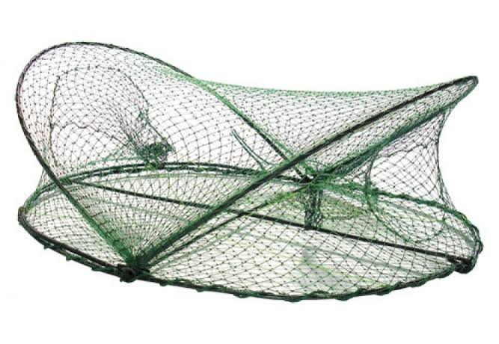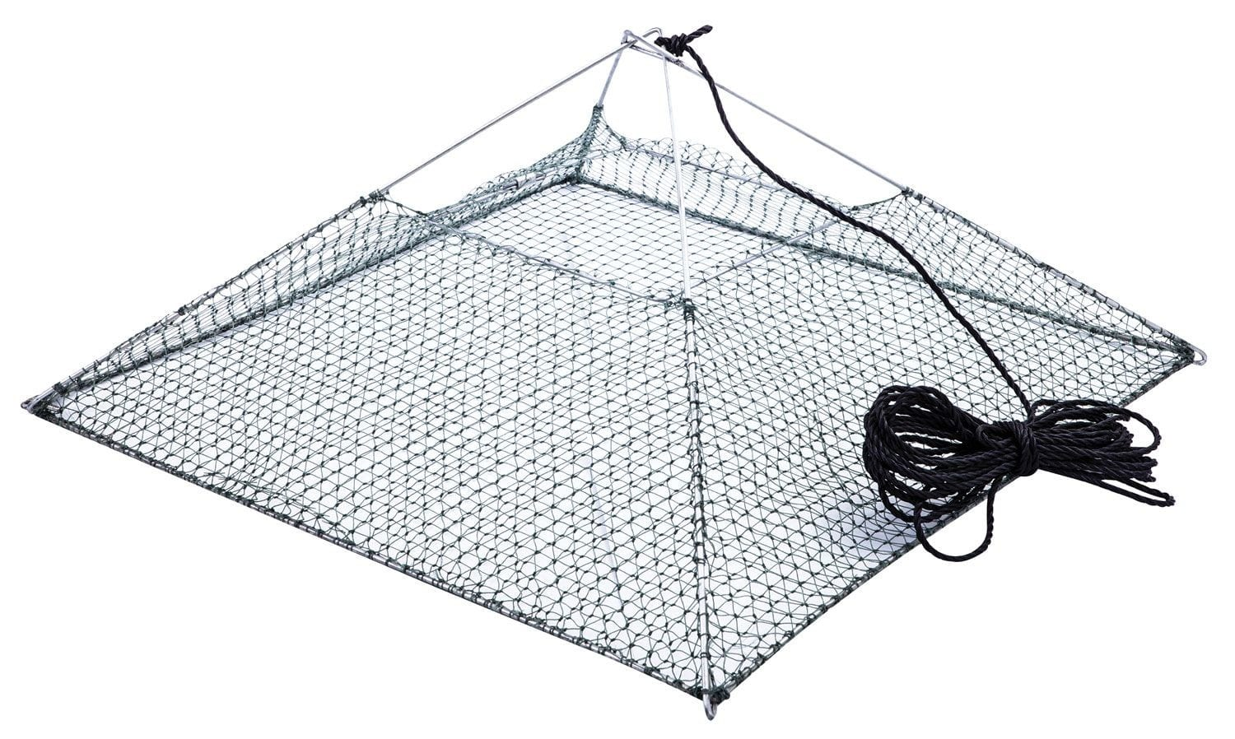
Outdated (enclosed yabby trap) Safe alternative (open-top pyramid net)

I am asking the Queensland Government to follow the lead of other states in Australia and:
- Implement legislation to ban enclosed yabby traps in all QLD waters,
- Prohibit the sale of enclosed yabby traps by all QLD retailers,
- Implement a net exchange program and phase out the use of enclosed yabby traps,
- Provide a detailed timeline for the implementation of the ban, and
- Education and enforcement around eliminating enclosed yabby traps and the potential danger to bycatch is needed.

I encourage your strong support for this action and acknowledging the receipt of this letter, please.

Yours Sincerely

[Your Name]
[Position if relevant]

